Shipment#: SHPDXBSI26000012
Freight Order#: EMA000162
Secondary PO Issue
If the EKPO Ref & Secondary PO is same then only we need to show the value in column EK PO Ref.
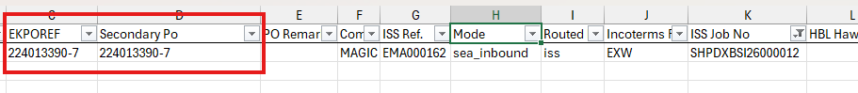
Port Details not showing
Origin Port Name, Country, Region not showing.
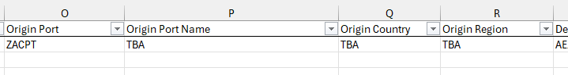

Carrier Name not showing
Aiden fixed the Carrier Name. But on the tracker it is still showing the Carrier Code.
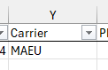
PO Appr Date Format Issue
Date value showing in the wrong format
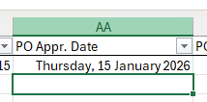
Pack Type Issue
Pack Type Column showing the code instead of the name.
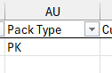
Shipment Remarks/Update Issue
Shipment Remarks/Update showing empty value but it is already updated in COMS
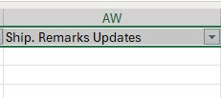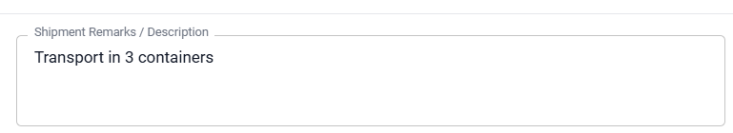
Missing values on COMS Fields
Below shown columns showing empty values even if there is data on COMS.
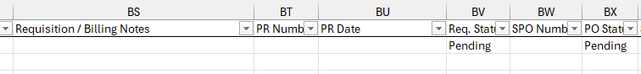
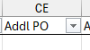
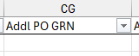
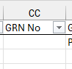
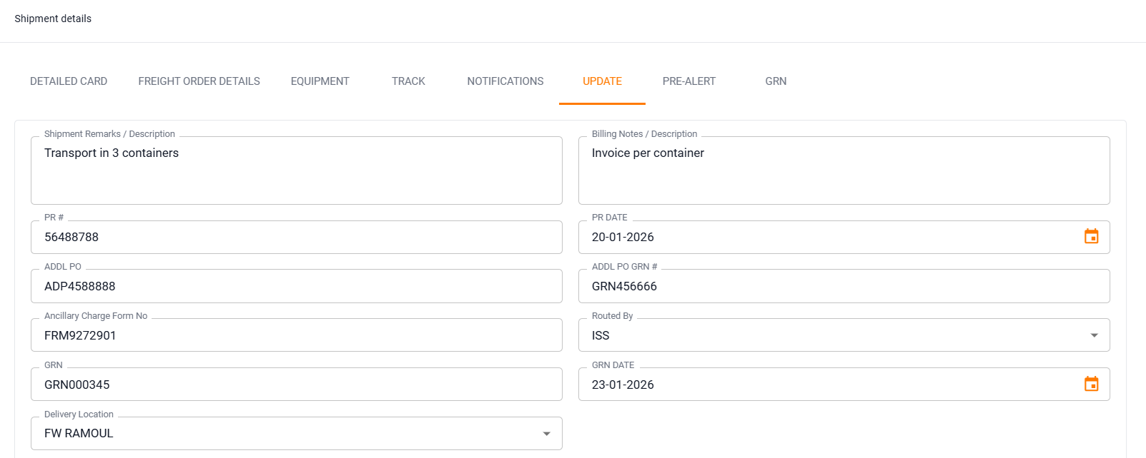
ISS Customs Clearance Perf % value issue
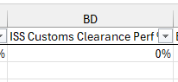
Showing 0% but it supposed to show -67%
Health Check issue

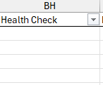
It supposed to show as “Healthy”
NBD to ETA issue
Showing empty values but it supposed to show “-57”
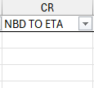

AVERAGE LT issue
Showing empty values but it supposed to show “28”
